# **Age Detection using Deep Learning in OpenCV**

Our goal here is to create a program that will predict the gender and age of the person using an image. But predicting age might not be as simple because age prediction is a regression problem, However, there are many uncertainties that researchers have faced when they treated this as a regression problem, like camera quality, brightness, climate condition, background, etc.

The solution to this problem is quite simple, instead of predicting an exact image, let’s classify the age into a specific range like 0-6,18-25, etc. And that’s what researchers did and found that the results were amazing and the accuracy rose up by a lot in real-world scenarios.

**Work Flow** :

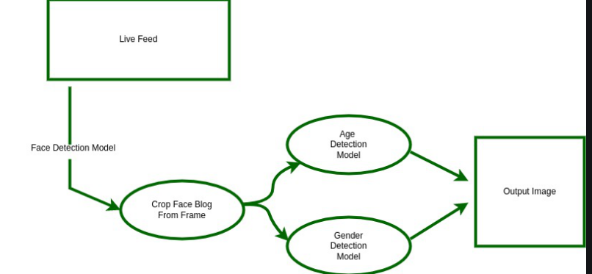

**Building the Main Program**

**Step 1: Creating the Image Instance**

Here we’re going to use the OpenCV package to instantiate an object for the input image,

**Step 2: Create DNNs Using the Models**

In OpenCV, we create a DNN – deep neural network to load a pre-trained model and pass it to the model files.

**Step 3: Face Detection**

For this program, I have used the **dlib.get_frontal_face_detector()** method for face detection

**Step 4: Age Detection**

Before we pass the image as an input we have to change it to the required dimensions i.e according to our model’s input layer,This is done by **blobFromImage()** function in OpenCV.

Then this blob is passed as an input to the age detector model.

**Step 5: Show The Resulting Image with Detection**

Now that we have the predictions, we’ll put them as text and show them in the final output image.

**Final Prediction Results :**

**Input 1 : woman1.jpg**

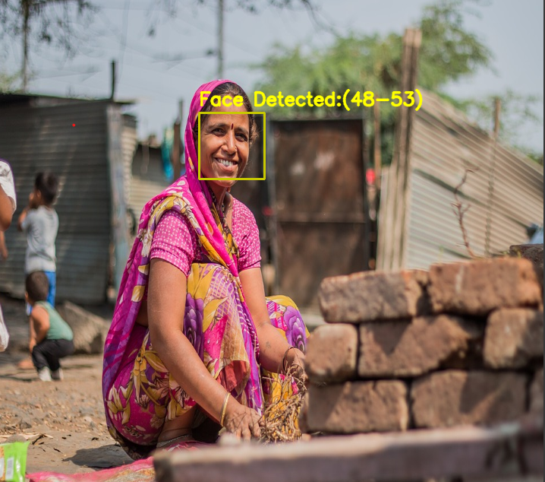

Face is detected successfully and age predicted in the range of

48-53

**Input 2: kid1.jpg**

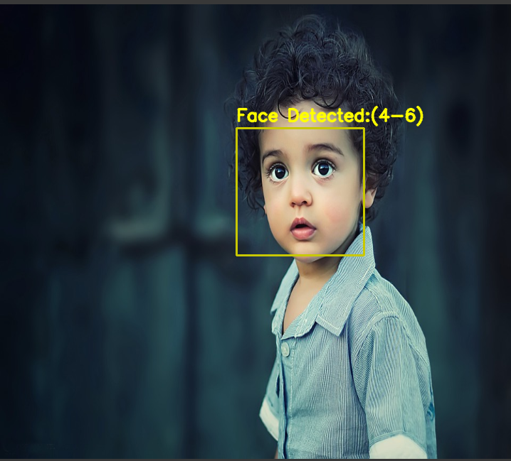

**Input 3: girl1.jpg**

